Social Security Authorization Instructions:

Please be sure to fill in all of the spots where the asterisks appear. This includes the following:
- Name
- Date of Birth
- Full Social Security Number
- Signature
- Date of Signature
- Daytime phone number
- Address

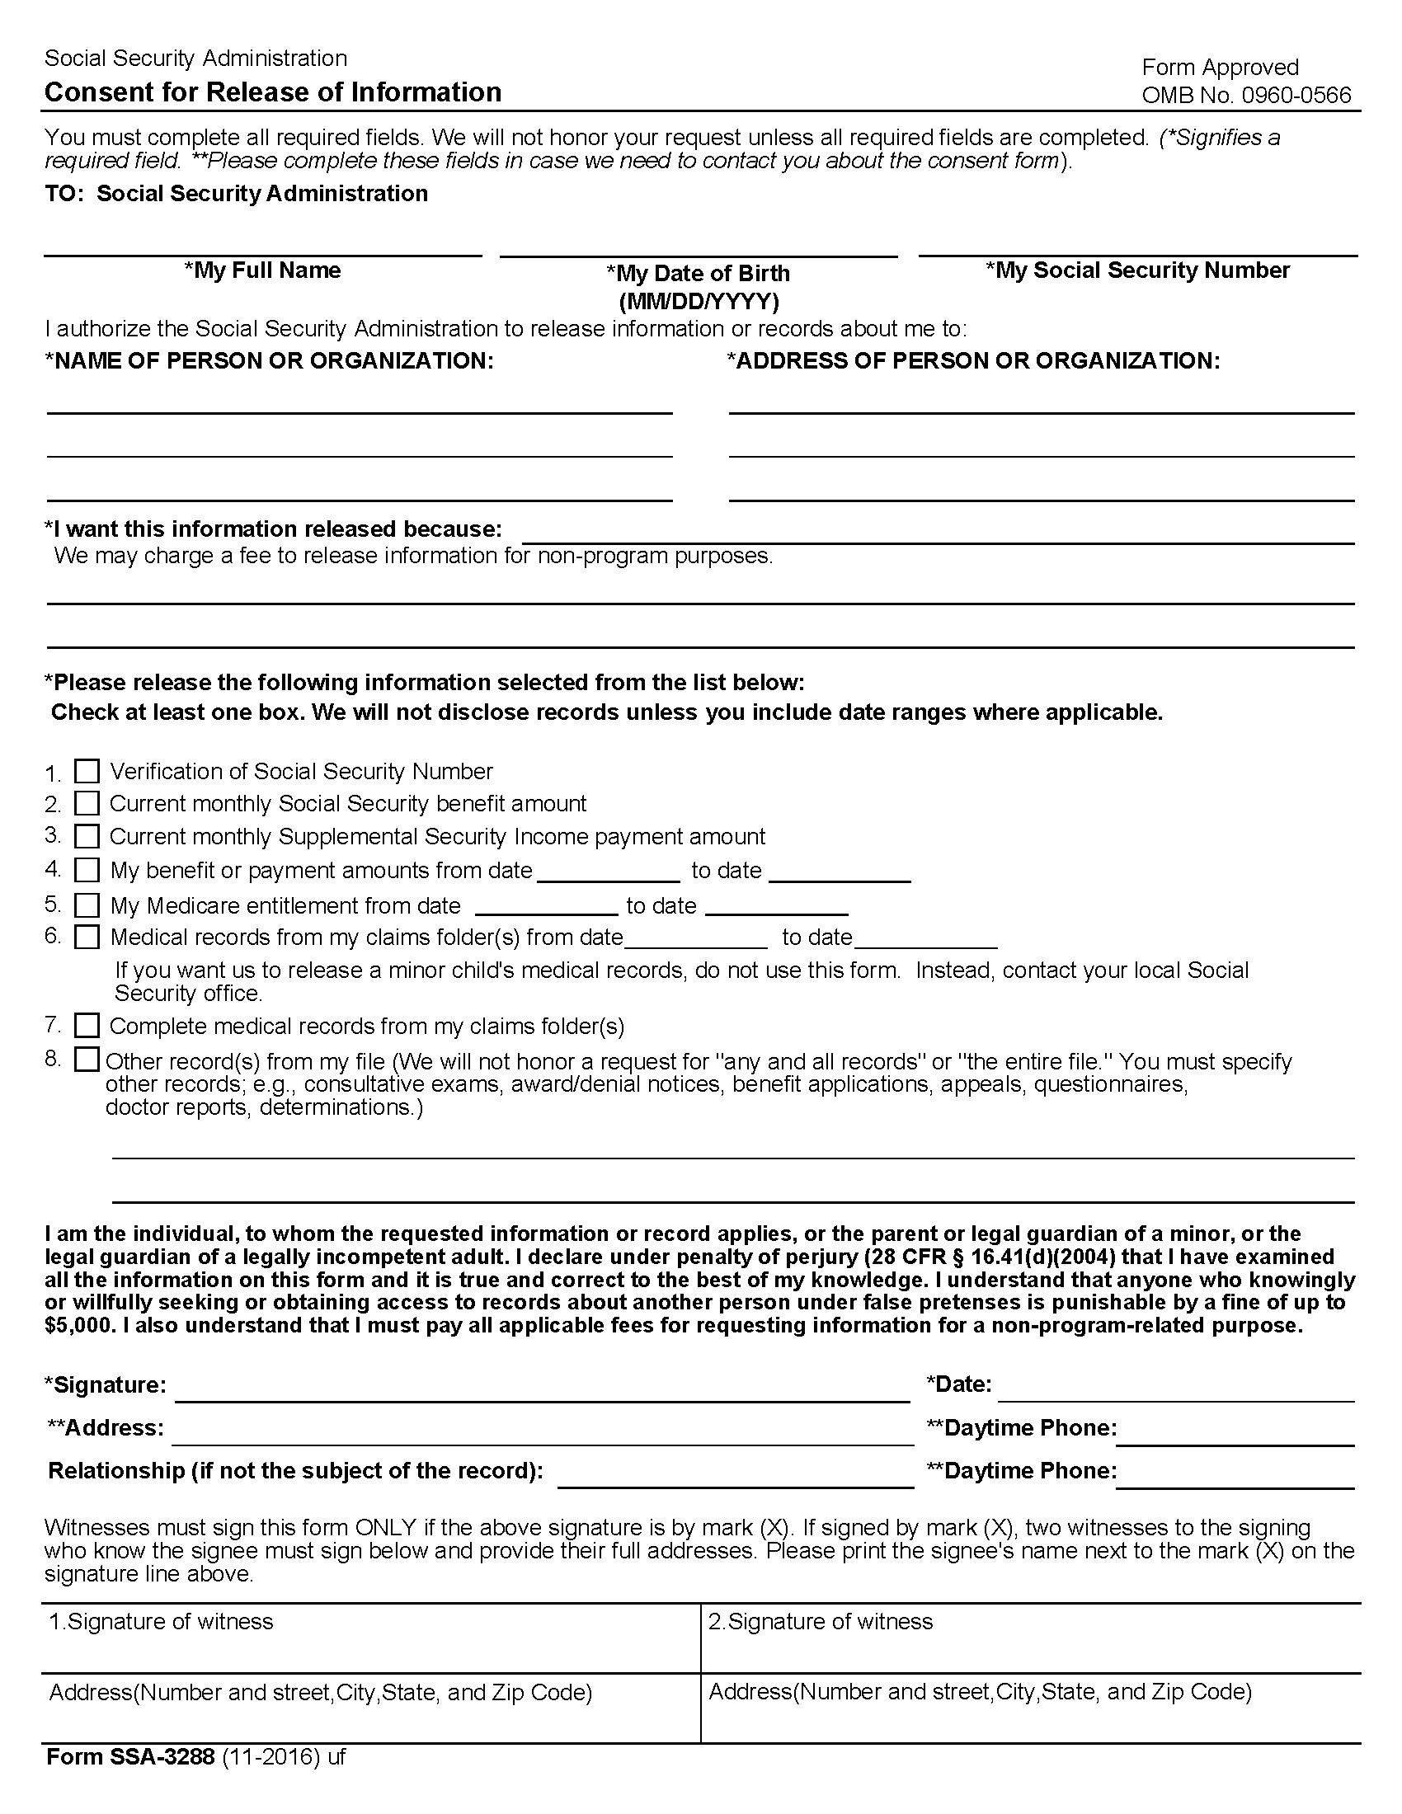
Batman
01/01/1979
xxx-xx-5555
Axiom Requisition Copy Service
2869 Jolly Road
Okemos, MI 48864
Litigation
01/01/1979
Present
01/01/1979
Present
✓
✓
✓
✓
✓
✓
✓
Application for Benefits, Application for Supplemental Security Income, Award Sheets, Determination Reports,
all doctors reports and all questionnaires

